**HANGMAN GAME**

* PROJECT DETAILS

We have made a hangman game using python tkinter module. The game is to guess the movie name within 7 chances. A set of 3 hints is provided to the player to help him. However, using the hints causes the player to lose one chance.

* PROJECT SCREENSHOTS

1. The app opens to the rules of the game in a message box

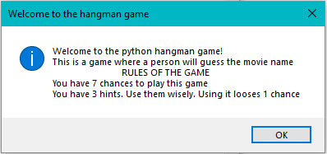

1. After closing the text box, the following window appears showing blank boxes for the movie name, buttons for alphabets, a hangman figure and a hint box.

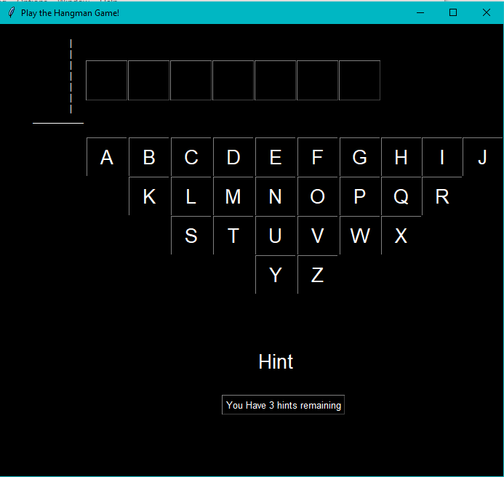

1. 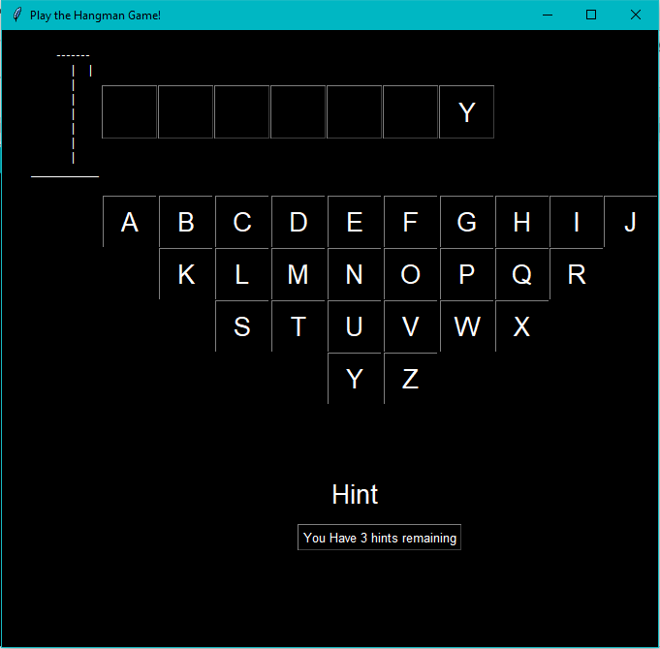This is the window after 1 wrong letter(Z) and one correct letter(Y) is entered. The hangman has increased.
2. 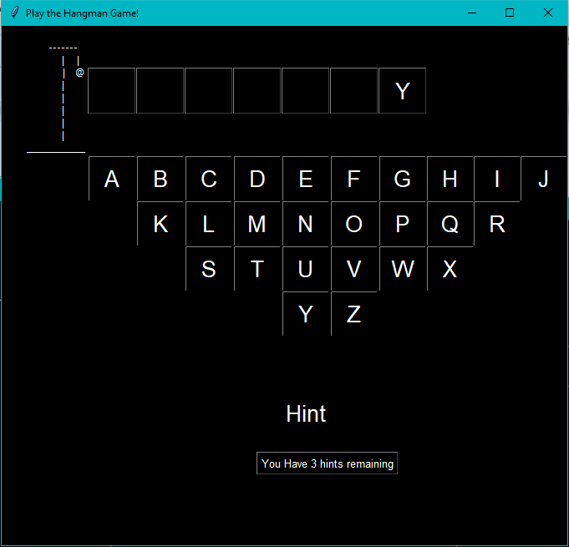Another wrong letter is entered
3. 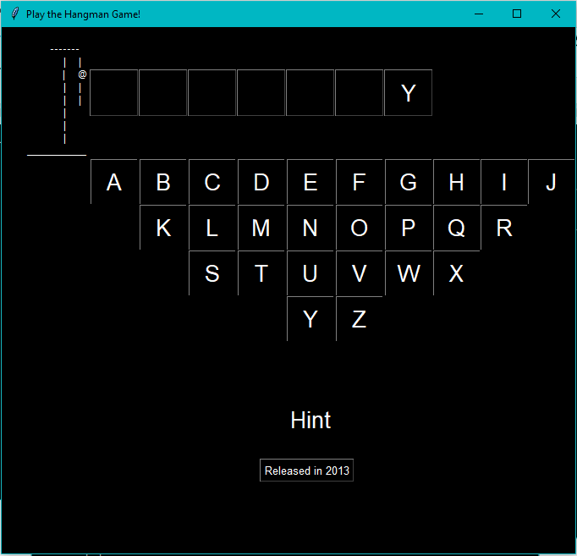One Hint is utilized it is displayed below the hint box.
4. 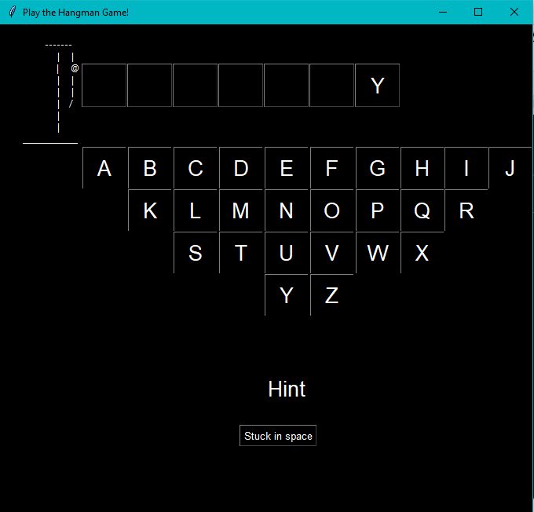Another hint utilized
5. 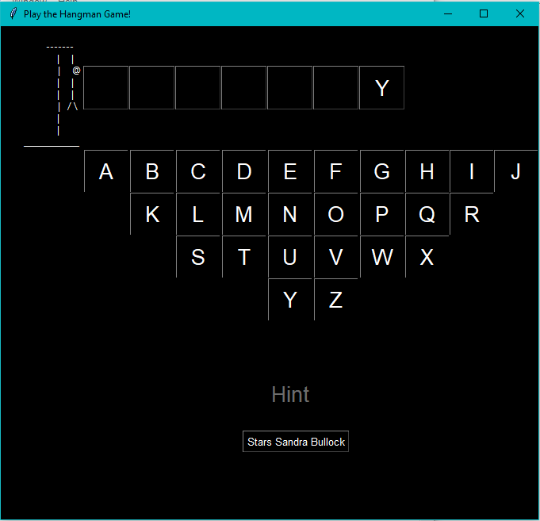All Hints are utilized and a message box stating this is displayed.

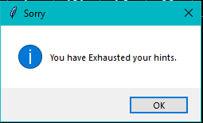

1. Two correct letters entered.

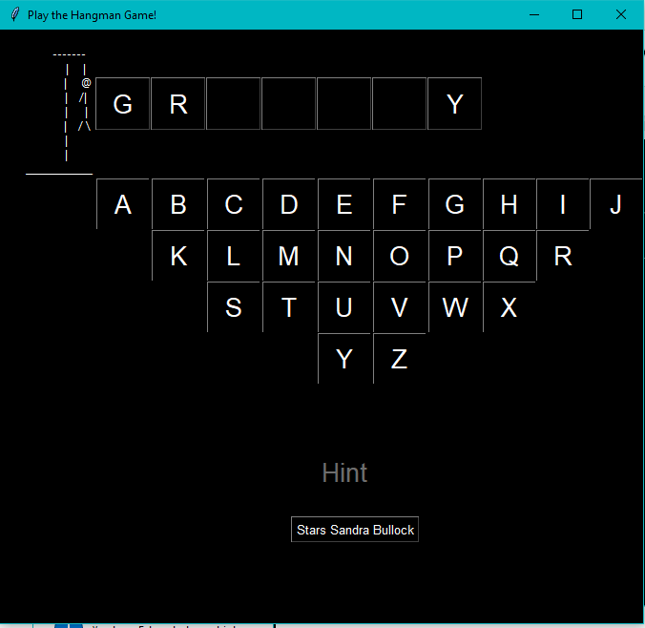

1. 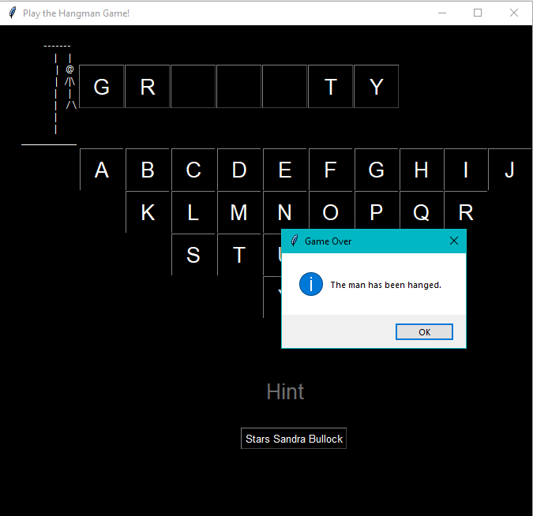All chances exhausted.
2. 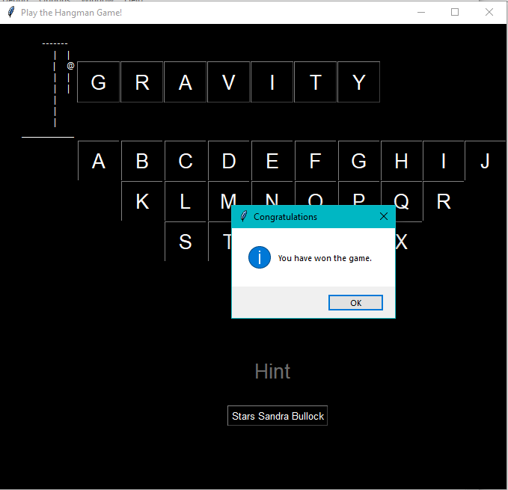The movie name is guessed correctly

* PROJECT CODE

#IMPORTING THE MODULES

from tkinter import *

from tkinter import messagebox

import random

import time

from DIC import dic,hangman

import sys

#CREATION OF WINDOW AND CHOOSING OF MOVIE

window = Tk()

window.title("Play the Hangman Game!")

window.configure(background="black")

movie=random.choice(list(dic.keys()))

time.sleep(1)

chances=7

#GENERATION OF MESSAGE BOX SHOWING THE RULES

messagebox.showinfo("Welcome to the hangman game","""Welcome to the python hangman game!

This is a game where a person will guess the movie name

RULES OF THE GAME

You have {} chances to play this game

You have 3 hints. Use them wisely. Using it looses 1 chance""".format(chances))

#INITIALIZING VARIABLES FOR FUNCTION DEFINITION

num=0

count=0

countspace=0

answer= movie

wrong=[]

#FUNCTION DEFINITION FOR WHEN THE BUTTONS ARE CLICKED

def clicked(alphabet):

global chances

global num

global count

global hintlab

global countspace

global answer

global label2

global wrong

global label3

#DISPLAYS HINTS

if alphabet=='Hints' and num<=2:

txt=dic[movie][num]

label2.configure(text=txt)

num+=1

chances-=1

txt=hangman[chances]

label3.configure(text=txt)

if num==3:

#DISPLAYS THE MESSAGE BOX FOR SHOWING THE HINTS ARE EXHAUSTED

messagebox.showinfo("Sorry","You have Exhausted your hints.")

btn27=Button(window, text="Hint",bg="black", fg="white",width=3,height=1,font=('Helvetica','20'), borderwidth=0, command=lambda: clicked("Hints"),state=DISABLED ).grid(column=5,row=7)

#DIPLAYING THE ALPHABET IF IT IS RIGHT

elif alphabet in answer:

for j in range(len(movie)):

if movie[j]==alphabet:

textboxes[j]=Button(window, text=alphabet ,bg="black", fg="white",width=3,height=1,font=('Helvetica','20')).grid(column=j+1, row=0)

count+=1

answer=answer[:answer.find(movie[j])]+answer[answer.find(movie[j])+1:]

wrong+=[alphabet]

else:

if count==(len(movie)-countspace):

#CHECKS WHETHER ALL THE LETTERS HAVE BEEN ENTERED

messagebox.showinfo("Congratulations","You have won the game.")

window.destroy()

quit()

elif alphabet not in wrong:

#DECREASES THE CHANCES AND UPDATES THE HANGMAN

wrong+=[alphabet]

chances = chances - 1;

txt=hangman[chances]

label3.configure(text=txt)

if chances<=0:

messagebox.showinfo("Game Over","The man has been hanged.")

window.destroy()

sys.exit()

#PRINTING THE EMPTY TEXTBOXES FOR THE MOVIE NAME

textboxes={}

for i in range(len(movie)):

if movie[i]!=" ":

textboxes[i] = Button(window, text="",bg="black", fg="white",width=3,height=1,font=('Helvetica','20')).grid(column=i+1, row=0)

else:

textboxes[i]=Label(window,text=" ",bg="black", fg="white").grid(column=i+1,row=0)

countspace+=1

num=0

Label(window,text="""efefefefefef

fefefefefefe

efefefef

""",fg="black",bg="black").grid(column=0,row=10)

#PRINTING THE ALPHABETS

btn1 = Button(window, text="A",bg="black", fg="white",width=3,height=1,font=('Helvetica','20'),borderwidth=1,command=lambda: clicked("A")).grid(column=1, row=2)

btn2 = Button(window, text="B",bg="black", fg="white",width=3,height=1,font=('Helvetica','20'),borderwidth=1,command=lambda: clicked("B")).grid(column=2, row=2)

btn3 = Button(window, text="C",bg="black", fg="white",width=3,height=1,font=('Helvetica','20'),borderwidth=1,command=lambda: clicked("C")).grid(column=3, row=2)

btn4 = Button(window, text="D",bg="black", fg="white",width=3,height=1,font=('Helvetica','20'),borderwidth=1,command=lambda: clicked("D")).grid(column=4, row=2)

btn5 = Button(window, text="E",bg="black", fg="white",width=3,height=1,font=('Helvetica','20'),borderwidth=1,command=lambda: clicked("E")).grid(column=5, row=2)

btn6 = Button(window, text="F",bg="black", fg="white",width=3,height=1,font=('Helvetica','20'),borderwidth=1,command=lambda: clicked("F")).grid(column=6, row=2)

btn7 = Button(window, text="G",bg="black", fg="white",width=3,height=1,font=('Helvetica','20'),borderwidth=1,command=lambda: clicked("G")).grid(column=7, row=2)

btn8 = Button(window, text="H",bg="black", fg="white",width=3,height=1,font=('Helvetica','20'),borderwidth=1,command=lambda: clicked("H")).grid(column=8, row=2)

btn9 = Button(window, text="I",bg="black", fg="white",width=3,height=1,font=('Helvetica','20'),borderwidth=1,command=lambda: clicked("I")).grid(column=9, row=2)

btn10 = Button(window, text="J",bg="black", fg="white",width=3,height=1,font=('Helvetica','20'),borderwidth=1,command=lambda: clicked("J")).grid(column=10, row=2)

btn11= Button(window, text="K",bg="black", fg="white",width=3,height=1,font=('Helvetica','20'),borderwidth=1,command=lambda: clicked("K")).grid(column=2, row=3)

btn12 = Button(window, text="L",bg="black", fg="white",width=3,height=1,font=('Helvetica','20'),borderwidth=1,command=lambda: clicked("L")).grid(column=3, row=3)

btn13 = Button(window, text="M",bg="black", fg="white",width=3,height=1,font=('Helvetica','20'),borderwidth=1,command=lambda: clicked("M")).grid(column=4, row=3)

btn14 = Button(window, text="N",bg="black", fg="white",width=3,height=1,font=('Helvetica','20'),borderwidth=1,command=lambda: clicked("N")).grid(column=5, row=3)

btn15= Button(window, text="O",bg="black", fg="white",width=3,height=1,font=('Helvetica','20'),borderwidth=1,command=lambda: clicked("O")).grid(column=6, row=3)

btn16 = Button(window, text="P",bg="black", fg="white",width=3,height=1,font=('Helvetica','20'),borderwidth=1,command=lambda: clicked("P")).grid(column=7, row=3)

btn17 = Button(window, text="Q",bg="black", fg="white",width=3,height=1,font=('Helvetica','20'),borderwidth=1,command=lambda: clicked("Q")).grid(column=8, row=3)

btn18 = Button(window, text="R",bg="black", fg="white",width=3,height=1,font=('Helvetica','20'),borderwidth=1,command=lambda: clicked("R")).grid(column=9, row=3)

btn19 = Button(window, text="S",bg="black", fg="white",width=3,height=1,font=('Helvetica','20'),borderwidth=1,command=lambda: clicked("S")).grid(column=3, row=4)

btn20 = Button(window, text="T",bg="black", fg="white",width=3,height=1,font=('Helvetica','20'),borderwidth=1,command=lambda: clicked("T")).grid(column=4, row=4)

btn21 = Button(window, text="U",bg="black", fg="white",width=3,height=1,font=('Helvetica','20'),borderwidth=1,command=lambda: clicked("U")).grid(column=5, row=4)

btn22 = Button(window, text="V",bg="black", fg="white",width=3,height=1,font=('Helvetica','20'),borderwidth=1,command=lambda: clicked("V")).grid(column=6, row=4)

btn23 = Button(window, text="W",bg="black", fg="white",width=3,height=1,font=('Helvetica','20'),borderwidth=1,command=lambda: clicked("W")).grid(column=7, row=4)

btn24 = Button(window, text="X",bg="black", fg="white",width=3,height=1,font=('Helvetica','20'),borderwidth=1,command=lambda: clicked("X")).grid(column=8, row=4)

btn25 = Button(window, text="Y",bg="black", fg="white",width=3,height=1,font=('Helvetica','20'),borderwidth=1,command=lambda: clicked("Y")).grid(column=5, row=5)

btn26 = Button(window, text="Z",bg="black", fg="white",width=3,height=1,font=('Helvetica','20'),borderwidth=1,command=lambda: clicked("Z")).grid(column=6, row=5)

#VISUAL REPRESENTATION AND SPACING

Label(window,text="""efefefefefef

fefefefefefe

efefefef

""",bg="black", fg="black").grid(column=0,row=6)

Label(window,text="""efefefefefef

fefefefefefe

efefefef

""",bg="black", fg="black").grid(column=0,row=8)

Label(window,text="""efefefefefef

fefefefefefe

""",bg="black", fg="black").grid(column=0,row=10)

label2=Button(window,text="You Have 3 hints remaining",font=('Helvetica','10'),bg="black", fg="white")

label2.place(x=305,y=510)

#DISPLAYING THE HANGMAN

label3=Label(window,text="""

|

|

|

|

|

|

|

______________

""",fg="white",bg="black")

label3.grid(column=0,row=0)

#DISPLAYING THE HINT BUTTON

btn27=Button(window, text="Hint",bg="black", fg="white",width=3,height=1,font=('Helvetica','20'), borderwidth=0, command=lambda: clicked("Hints") ).grid(column=5,row=7)

window.mainloop()

sys.exit()

**DIC.py**

#DICTIONARY CONTAINING ALL THE MOVIES

dic = {"AVENGERS ENDGAME": ("Released in 2019", "Produced by Marvel", "Highest grossing film"),

"READY PLAYER ONE": ("Released in 2018", "Directed by Steven Speilberg", "On Pop Culture"),

"JOKER": ("Released in 2019", "You wouldn't get it", "On mental health"),

"MISSION IMPOSSIBLE": ("Released in 1996", "Stars Tom Cruise", "A sequel was shot in Dubai"),

"SPIES IN DISGUISE": ("Released in 2019","Starring Will Smith","Also Starring Tom Holland"),

"HOME ALONE": ("Released in 1990", "Christmas Classic", "Starring Macaulay Culkin"),

"THE DARK KNIGHT": ("Released 2008", "Directed by Christopher Nolan", "Batman Trilogy"),

"JOHN WICK": ("Released in 2014", "DOGS", "Stars Keanu Reeves"),

"TERMINATOR": ("Released in 1984", "Stars Arnold Schwarzenegger", "Metal Robot"),

"THE MATRIX": ("Released in 1999", "Stars Keanu Reeves", "This is a simulation"),

"DEADPOOL": ("Released 2016", "Stars Ryan Reynolds", "Foul Mouth Assassin"),

"BABY DRIVER": ("Released 2017", "Stars Ansel Elgort", "Was he slow?"),

"GRAVITY": ("Released in 2013", "Stuck in space", "Stars Sandra Bullock"),

"THE SOCIAL NETWORK": ("Released in 2010", "Stars Jesse Eisenberg", "About Facebook"),

"FORREST GUMP": ("Released in 1994", "Stars Tom Hanks", "Stupid is as stupid does"),

"JAWS": ("Released in 1975", "Directed by Steven Speilberg", "You're gonna need a bigger boat"),

"JURASSIC PARK": ("Released in 1993", "Directed by Steven Speilberg", "Dinosaurs"),

"BACK TO THE FUTURE": ("Released in 1985", "Stars Michael J Fox", "Critically acclaimed sci-fi movie"),

"TOY STORY": ("Released in 1994","First CGI movie", "To Infinity, and beyond!"),

"THE LION KING":("Released in 1994","Remade in 2019","Hakuna Matata"),

"GLADIATOR":("Released in 2000","Stars Joaquin Phoenix","Ancient Rome"),

"GHOSTBUSTERS": ("Released in 1984", "Flop 2016 reboot", "Who ya gonna call?"),

"WALL E": ("Released in 2008", "No spoken dialogues", "Two robots")

}

#TUPLE CONTAING ALL THE HANGMAN ADJUSTED FOR SPACING

hangman = ('''

-------

| |

| @

| /|\\

| |

| / \\

|

|

______________''',

'''

-------

| |

| @

| /|

| |

| / \\

|

|

______________''',

'''

-------

| |

| @

| |

| |

| / \\

|

|

______________''',

'''

-------

| |

| @

| |

| |

| /

|

|

______________''',

'''

-------

| |

| @

| |

| |

|

|

|

______________''',

'''

-------

| |

| @

|

|

|

|

|

______________''',

'''

-------

| |

|

|

|

|

|

|

______________

''',

'''

|

|

|

|

|

|

|

______________

'''

)